





SORU: A 3-ary max heap is like a binary max heap, but instead of 2 children, nodes have 3 children. Find mapping.

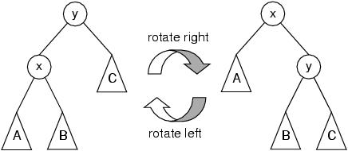 SORU: (20 pts.) We suppose that an AVL tree node has the following data structure.

struct node{  
 int key;  
 struct node \*left;  
 struct node \*right;  
 int height;  
 };

Complete the following function that performs right rotation. Note that height member of some nodes should be updated.

struct node \*rightRotate(struct node \*y){

…………………

return ….